**Lesson 10 Demo 01**

**Creating a React Test**

**Objective:** To create a simple React test with built-in Jest testing configuration to showcase the efficiency and ease of setting up a robust testing environment

**Tools required:** Node.js and React.js

**Prerequisites:** None

Steps to be followed:

1. Set up the React Jest project
2. Verify testing dependencies
3. Create an App.js component and App.test.js testing file
4. Test the application

**Step 1: Set up the React Jest project**

1. Open a terminal window to run the following command to create a React application:

**npx create-react-app react-simple-test**

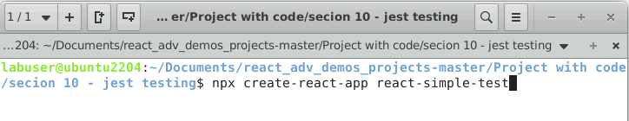

1. Open the terminal window inside the **react-simple-test** folder and run the **npm install** command to download the dependencies

1. Open the project in the VS Code editor and view the project structure

**Step 2: Verify testing dependencies**

1. Verify testing dependencies in **package.json** file as shown in the screenshot below:

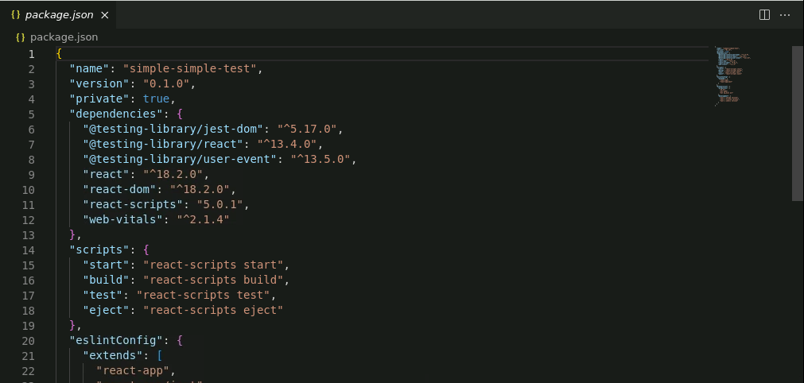

**Step 3: Create an App.js component and App.test.js testing file**

1. Create an **App.js** component with the following code:

**import logo from './logo.svg';**

**import './App.css';**

**function App() {**

**return (**

**<div className="App">**

**<header className="App-header">**

**<img src={logo} className="App-logo" alt="logo" />**

**<p>**

**Edit <code>src/App.js</code> and save to reload.**

**</p>**

**<a**

**className="App-link"**

**href="https://reactjs.org"**

**target="_blank"**

**rel="noopener noreferrer"**

**>**

**Learn React**

**</a>**

**</header>**

**</div>**

**);**

**}**

**export default App;**

**Note**: For the above component, React provides a sample testing file **App.test.js**. This file takes the help of the **@testing-library/react** module and tests the content present in JSX.

1. Create the **App.test.js** file with the following code:

**import { render, screen } from '@testing-library/react';**

**import App from './App';**

**test('renders learn react link', () => {**

**render(<App />);**

**const linkElement = screen.getByText(/learn react/i);**

**expect(linkElement).toBeInTheDocument();**

**});**

**Step 4: Test the application**

1. Open the terminal inside the project and run the application with the following command:

**npm test**

The output can be viewed on the terminal as shown below:

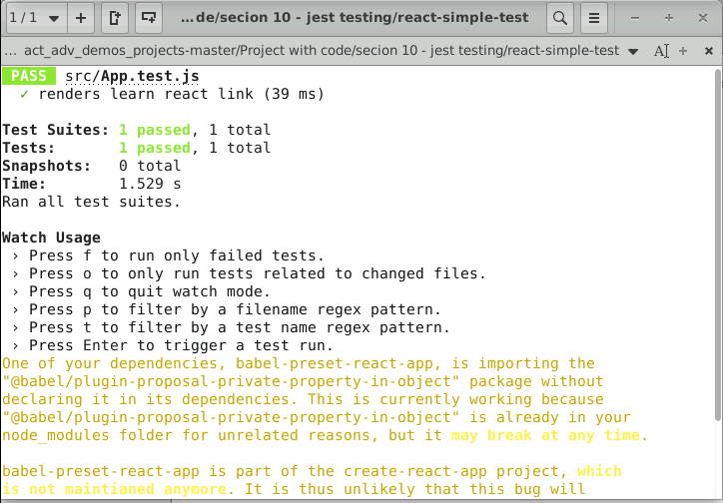

With this, you have successfully created a simple React test with a built-in Jest testing configuration.